Stationarity series:

A random process whose joint distribution doesn’t change over time.

Random process: future values cannot be predicted with certainty like stock price, totally probabilistic, non deterministic

Joint distribution : It combining two or more distributions , Y(t) & Y(t-s) , What is the probability that (Y(t)=10 & Y(t-s)=12) it will occur again

Strict Stationary

If the joint distribution of time series process remains same (unchanged) over time

|  |  |  |  |
| --- | --- | --- | --- |
|  | T1 | T2 | T3 |
| Y(t) | 200 | 220 | 231 |
| Y(t+s) | 180 | 195 | 210 |
| Prob | P1=P(y(t)=200, y(t+s)=180) | P1=P(y(t)=220, y(t+s)=195) | P1=P(y(t)=231, y(t+s)=210) |

If P1=P2=P3 , then we say strictly stationary i.e. joint probability does not over period of time, distribution does not change

Weak Stationary (covariance stationary)

* E(Yt)= mu constant mean
* E(Yt-mu)(yt-mu)= constant variance
* Constant auto covariance

AC(yt, yt-1)= AC(yt-5, yt-6)

AC(yt, yt+3) = AC(yt+5, yt+8)

Probability distribution could still differ, slightly relaxed.

All strictly stationary time series are weak stationary but not the other way around.

Auto Correlation Function (ACF)/ correalogram

In time series usually the current value can be derived by past value. This is done using auto correlation.

It is metric to quantify relationship of time series with past values

Finding the correlation with past values = Auto covariance/ variance

All lies between -1 to +1

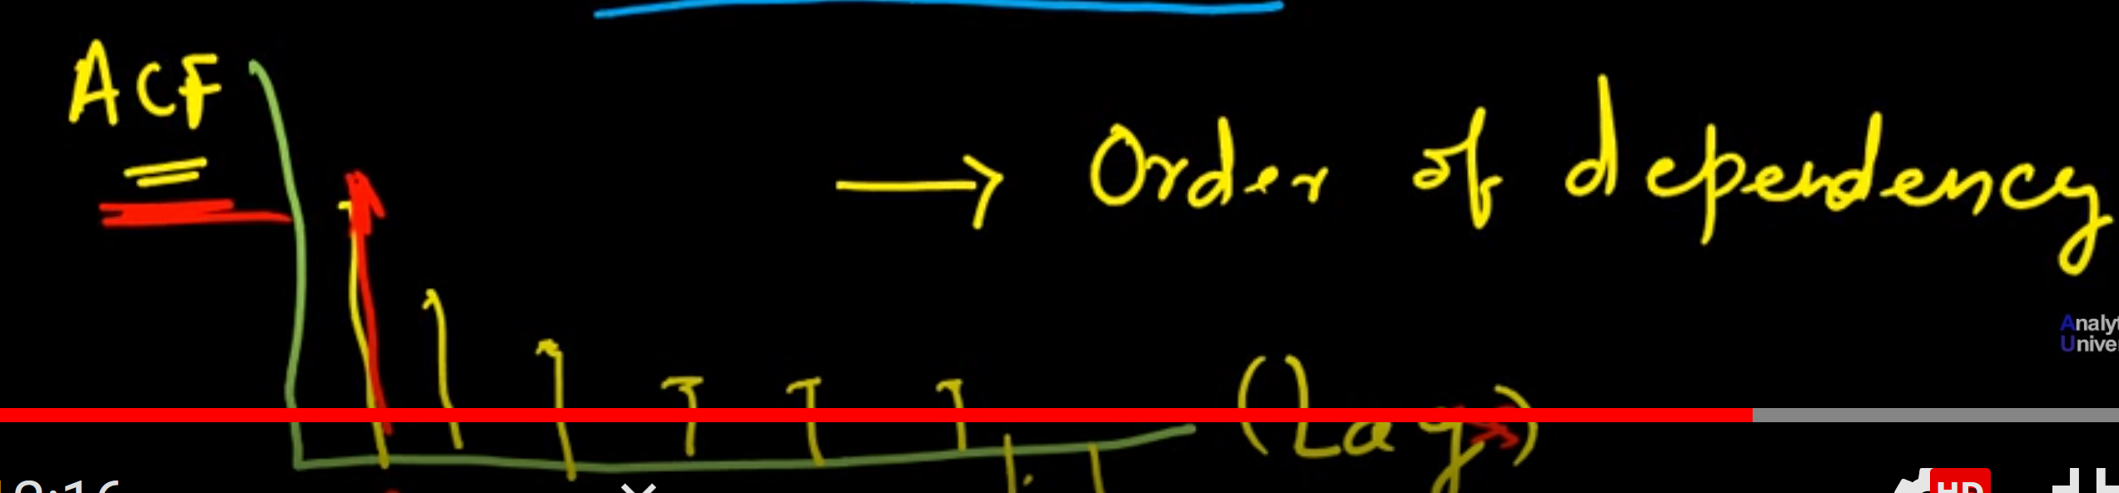

White Noise

A random process that satisfying the following

Constant mean and contarnt variance

And zero auto correlation

Each observation is uncorrelaed with other observation

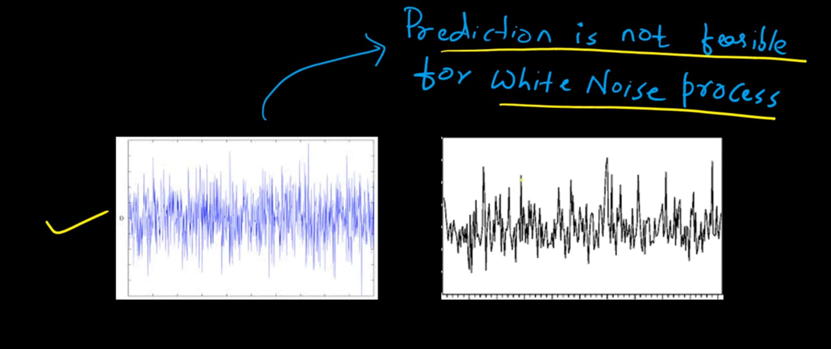

Ljung Box test is used to test whether the autocorrelation at particular lag is significant or not.

For stationary series correlation with increase in lags decreases, but for non-stationary process correlation with increase in lags increases.

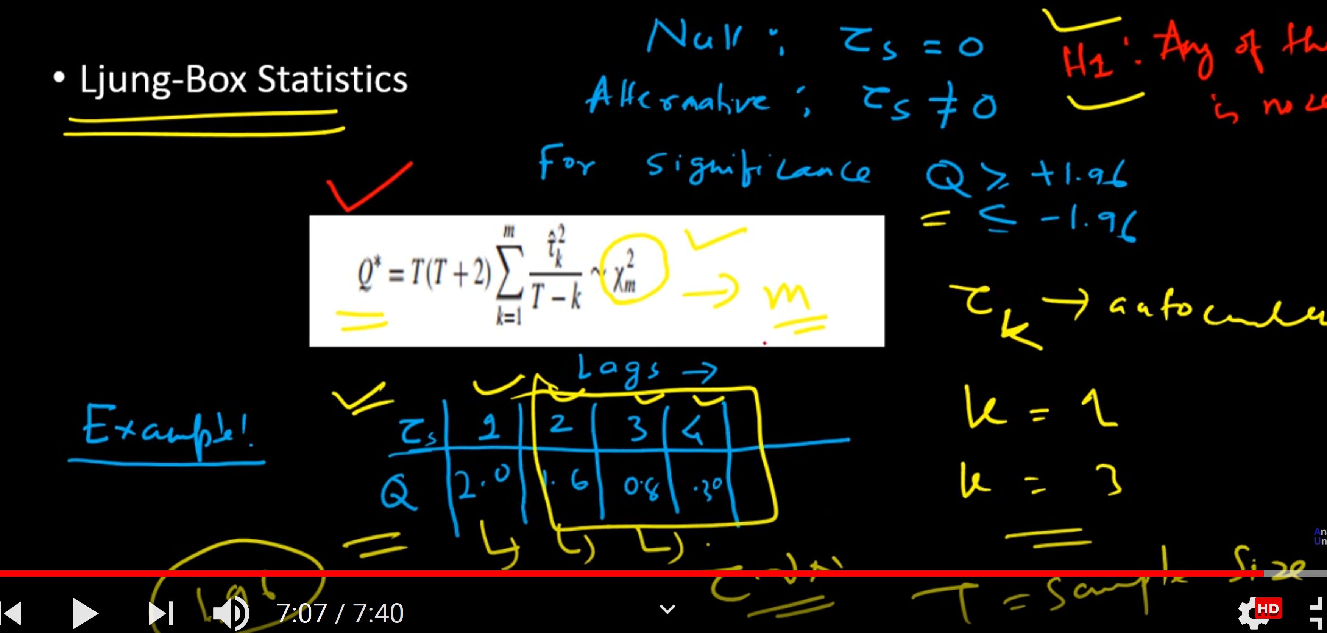

Here Tau is autocorrelation at particular lag K, T is ample side

From example only at lag 1 auto correction is signification as it is greater than +1.96. In other lags it is not significant so we can ignore them.

white noise has zero mean and 1 variance.

Check Stationary

Example1

Yt= yt-1+ut #this equation is also called random walk

Yt= Lyt+ut

Yt-Lyt= ut

Yt(1-L)=ut

In this example, Characteristic equation is (1-L), the roots of this characteristic equation should be greater than 1, lie outside the unit circle.

l-L=0

L=1

One root L, as L=1 it is non stationary time series.

Example 2

Yt= 3 Yt-1 -2.75 Yt-2+ 0.75 Yt-3+ ut

Yt= 3 LYt -2.75 L2 Yt+ 0.75 L3Yt+ ut

Ut is error term

Yt- 3 LYt +2.75 L2 Yt- 0.75 L3Yt = ut

Yt(1-3L+2.75L2 -0.75 L3) =0

After solving the equation or finding roots

(1-L)(1-1.5L)(1-0.5L)= 0

L=1, 1/1.5, 2

Only one root 2 is satisfying the stationary condition,that means it is non stationary

PACF is useful in detecting order of AR process

If ACF and PACF both start declining with lags it follows ARMA process.

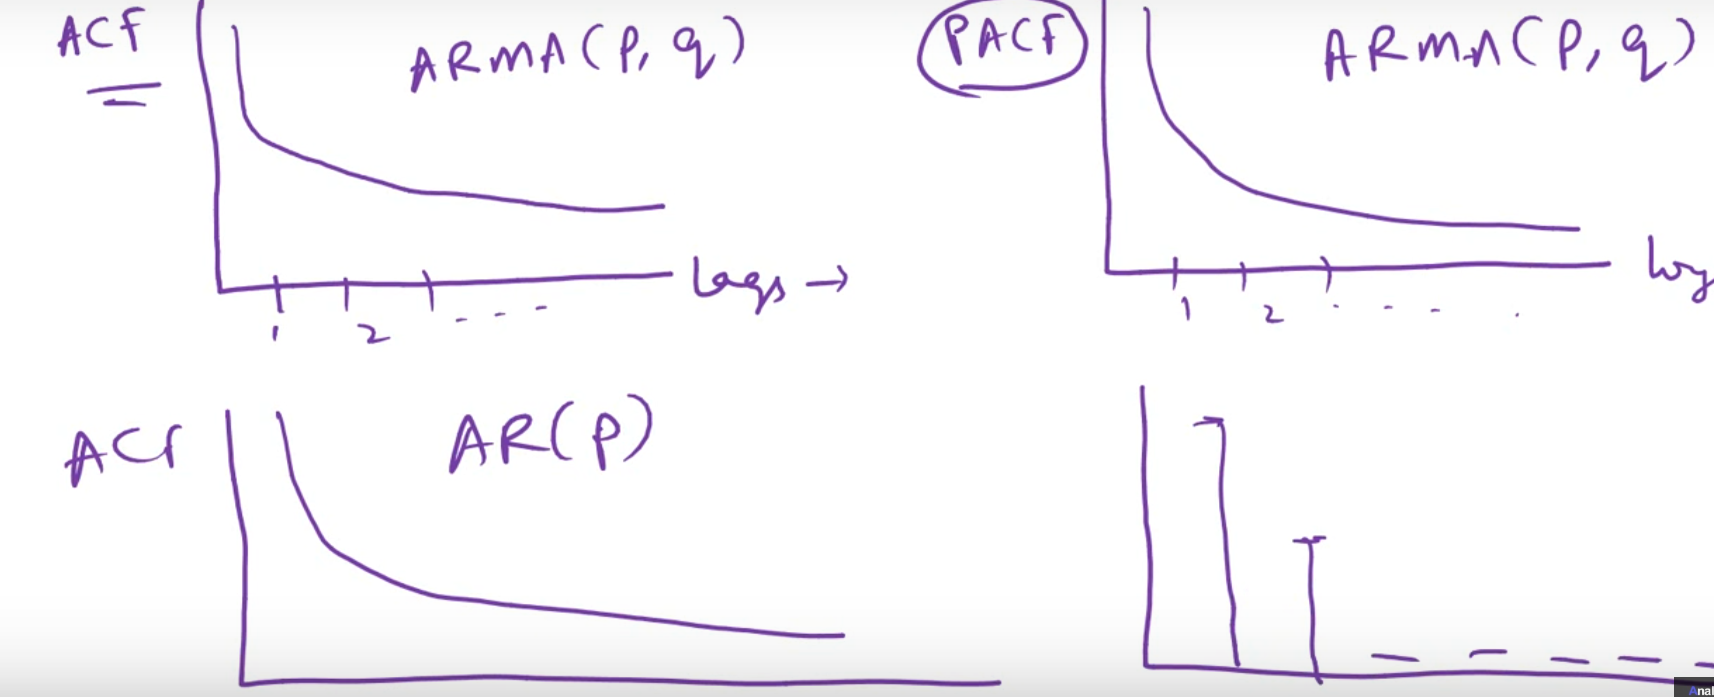

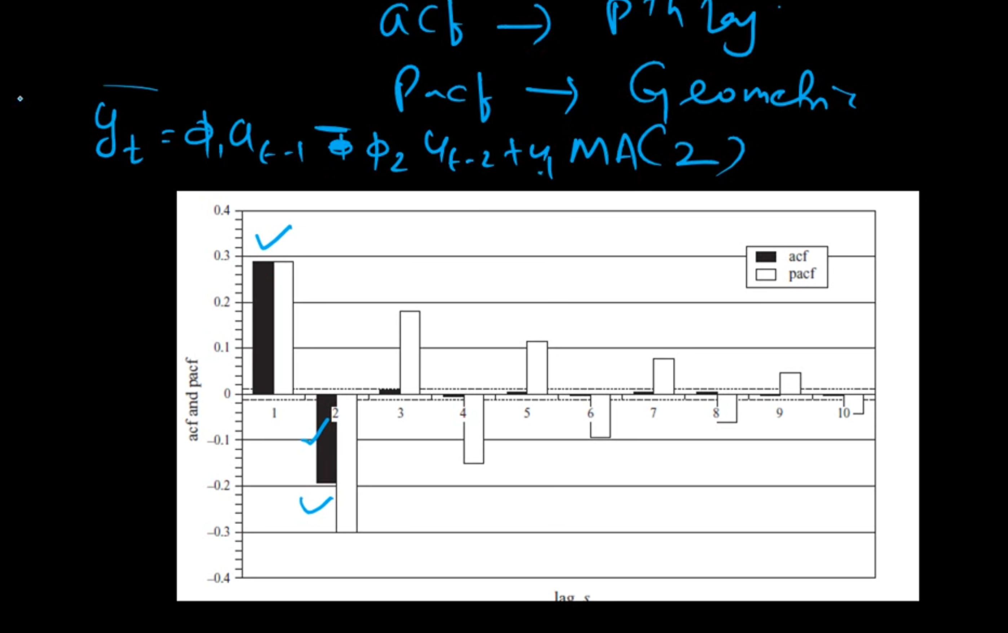

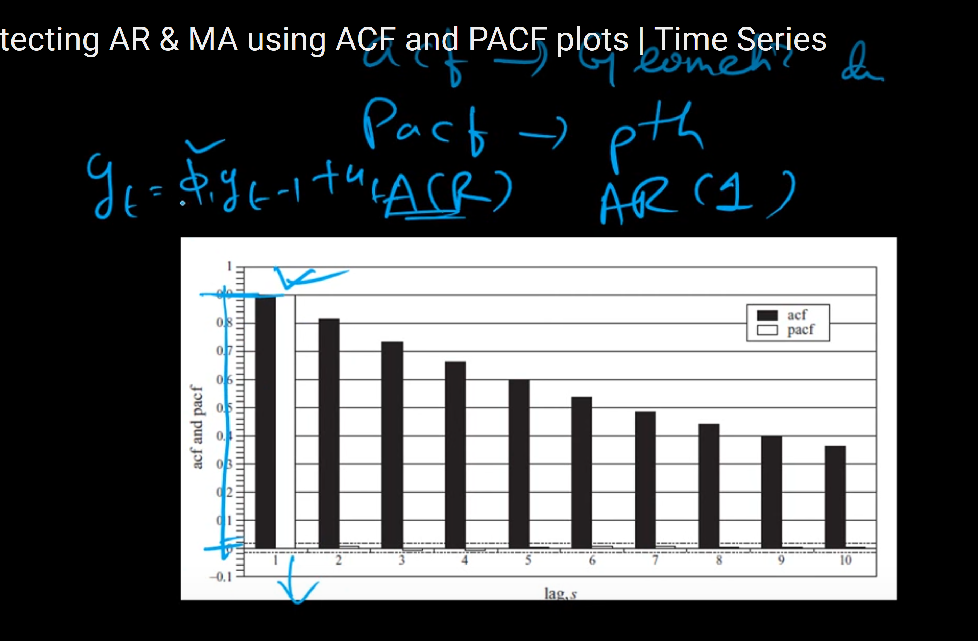

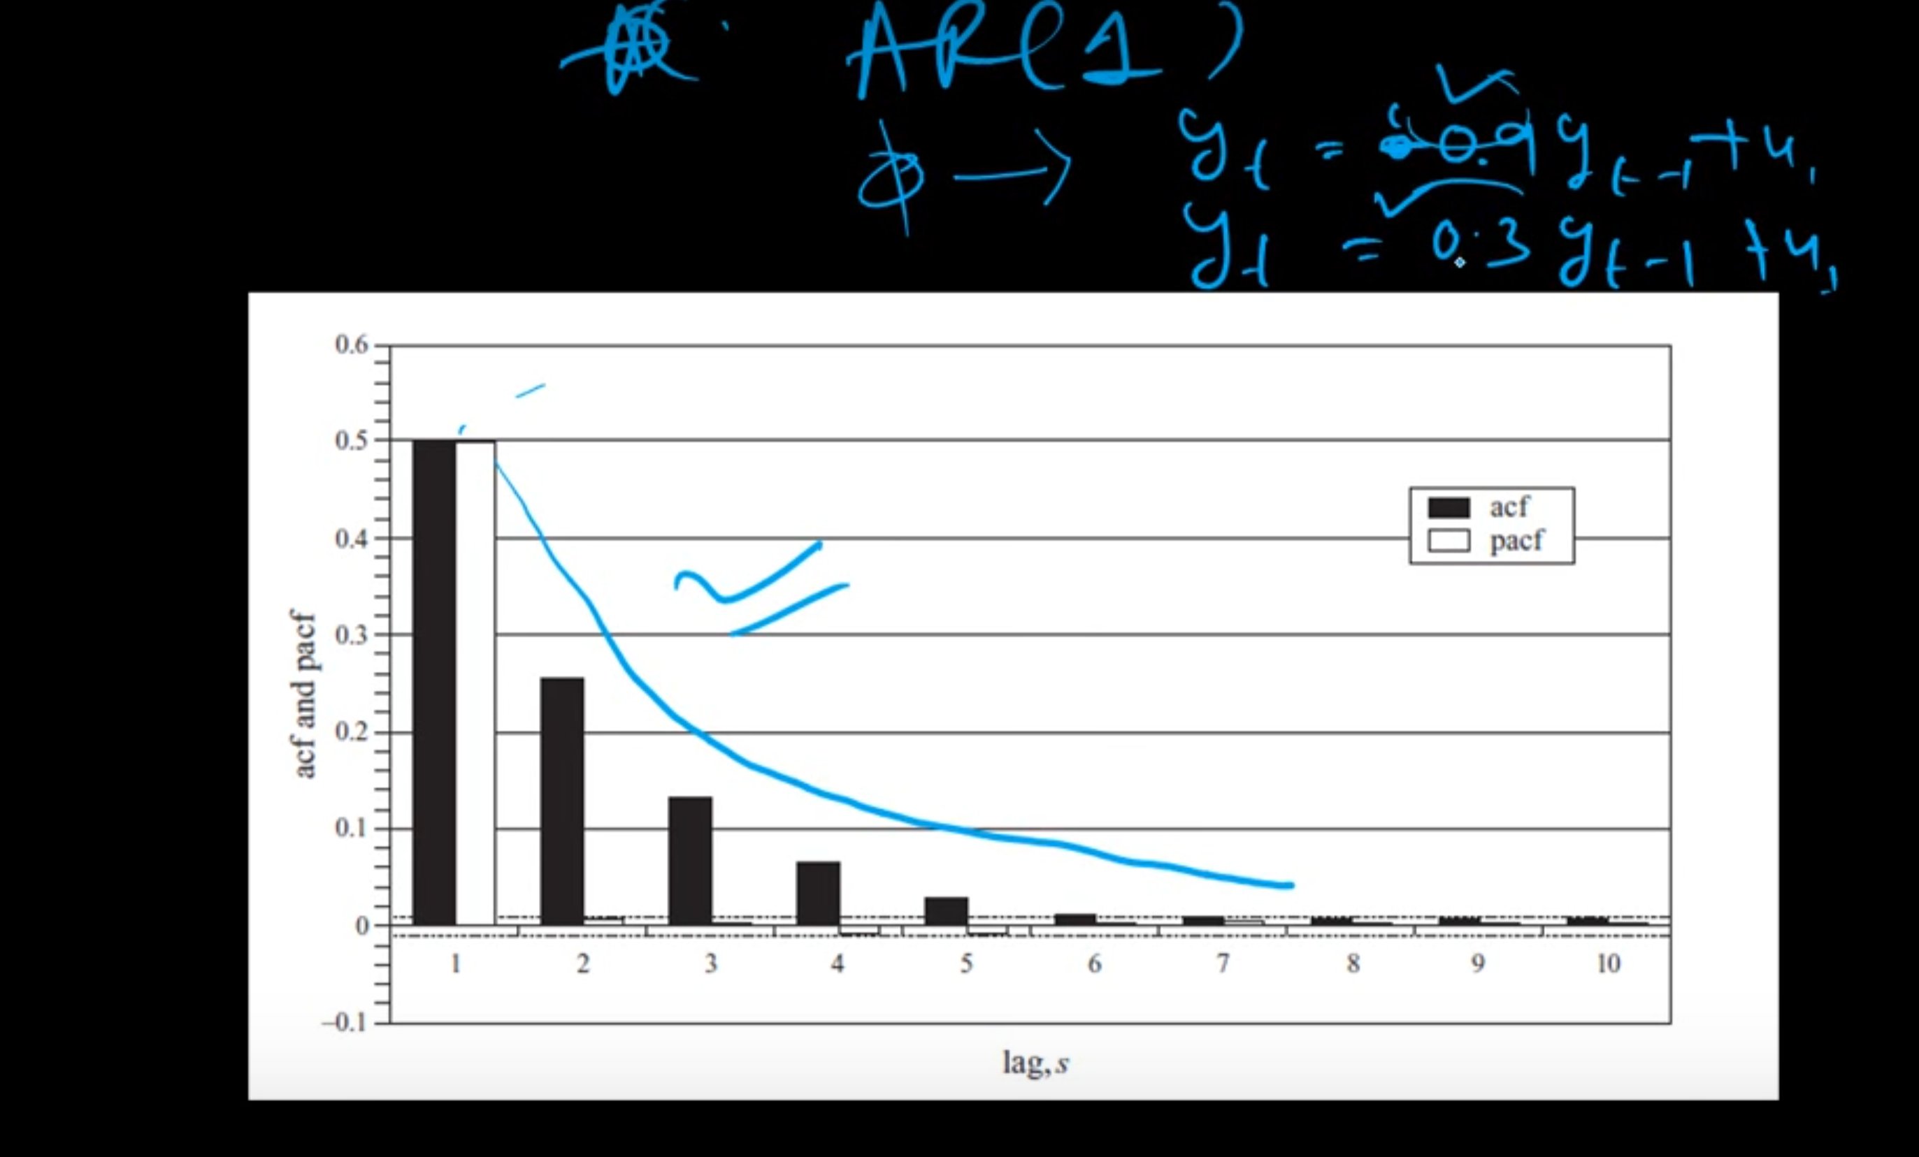

Smaller is the coefficient of Y(t-1), sharper the decay . larger the coefficient flat decay.

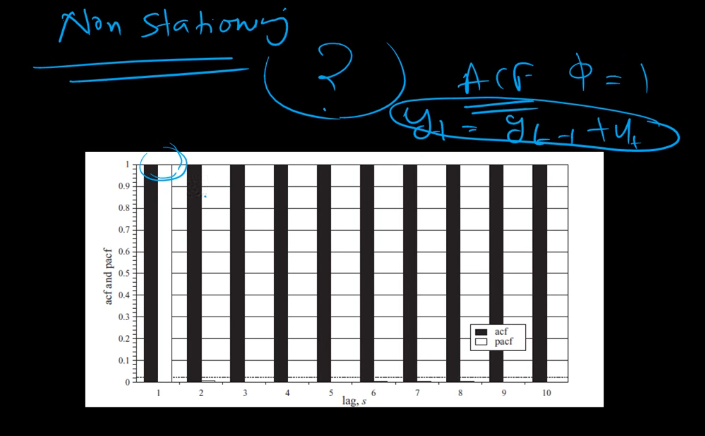

Box Jenkins approach (ARMA Model)

Identifaction, estimation, digonistic check

Step 1: determine the order of model ACF & PACF (p and q)

Step 2: Estimate the parameter (Phi, theta) using OLS or maximum likelihood

Step3: Overfitting/under fitting and residual diagnostic

Underfitting : auto correlation between residual terms

Information criteria for ARMA Model selection (p,q)

How to choose optimal p and q

Selecting model order of time series based on residual sum of square (RSS)

Min(F(RSS)+Penality term)

Trade off : Adding extra terms vs penalty

When we keep on adding new lag RSS will keep decreasing and decreasing, we will not be choose between ARMA(1,1) and ARMA(1,2), ARMA(2,2)

Parsimonious: simple enough to predict and less parameters

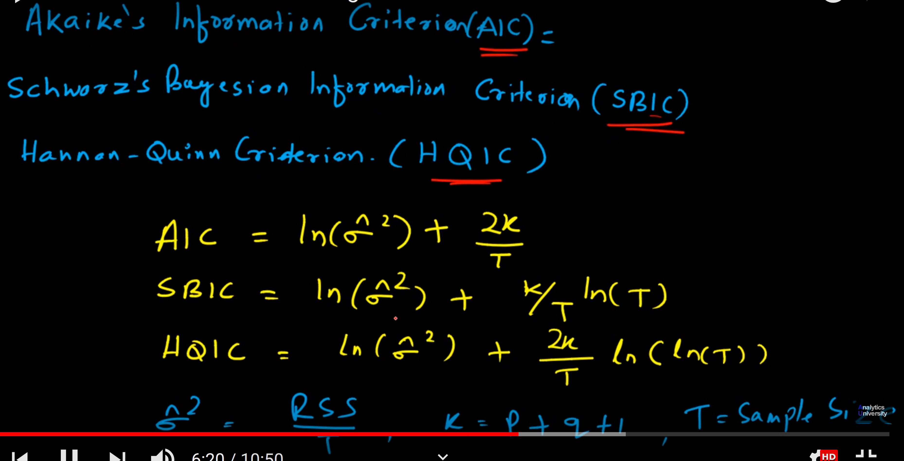

For all Information criteria error term is same, penalty term is differing,

Sigma ^2 = RSS/T

K= number of parameters+1

T= sample size

For whichever model AIC, BIC, HQIC value is less, will be the best model.

ARIMA Model

Differentiation makes series stationary

|  |  |  |  |  |  |  |  |  |  |
| --- | --- | --- | --- | --- | --- | --- | --- | --- | --- |
|  | Square | First Diff | Second Diff | |  | Cube |  |  |  |
| 1 | 1 |  |  |  |  | 1 |  |  |  |
| 2 | 4 | 3 |  |  |  | 8 | 7 |  |  |
| 3 | 9 | 5 | 2 |  |  | 27 | 19 | 12 |  |
| 4 | 16 | 7 | 2 |  |  | 64 | 37 | 18 | 6 |
| 5 | 25 | 9 | 2 |  |  | 125 | 61 | 24 | 6 |
| 6 | 36 | 11 | 2 |  |  | 216 | 91 | 30 | 6 |
| 7 | 49 | 13 | 2 |  |  | 343 | 127 | 36 | 6 |
| 8 | 64 | 15 | 2 |  |  | 512 | 169 | 42 | 6 |
| 9 | 81 | 17 | 2 |  |  | 729 | 217 | 48 | 6 |
| 10 | 100 | 19 | 2 |  |  | 1000 | 271 | 54 | 6 |
| 11 | 121 | 21 | 2 |  |  | 1331 | 331 | 60 | 6 |
| 12 | 144 | 23 | 2 |  |  | 1728 | 397 | 66 | 6 |

Stationary series means constant mean, variance, and constant autocorrelation

Non stationary time series have polynomial in equation.

https://www.youtube.com/watch?v=-vSzKfqcTDg&list=PLUgZaFoyJafhfcggaNzmZt_OdJq32-iFW&index=10

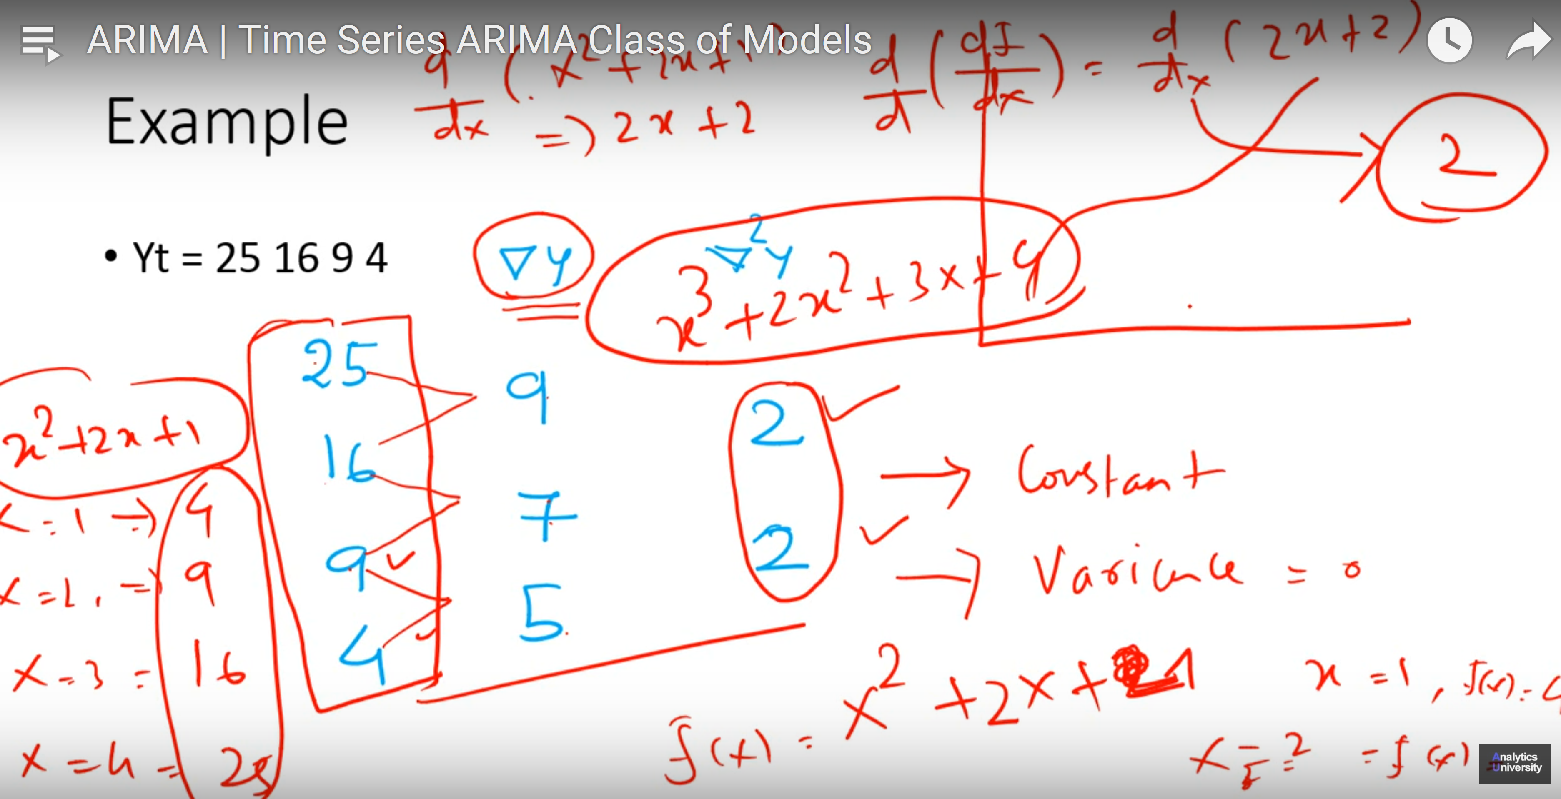

When we have 2 order in equation, atfter differentiating 2 times we get constant.

ARIMA(p, q, r)

P : AR terms

q= no of differentiation

r= no of MA terms

ARIMA(1,0,0) :AR model

ARIMA(0,0,1): MA model

ARIMA(1, 0, 1): ARMA model

ARIMA(0,1,0): random walk model yt-yt-1= error

AR phi<1, but random walk phi =1

Exponential smoothing model : ARIMA(0,1,1)

Take average of last few observations

Y(t)= y(t-1)

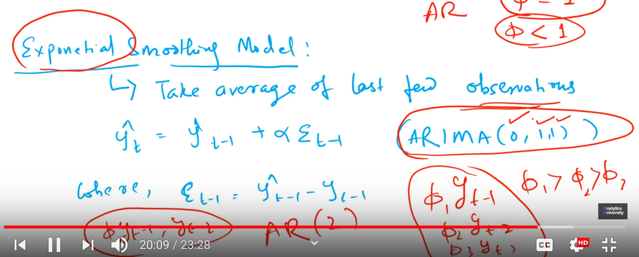

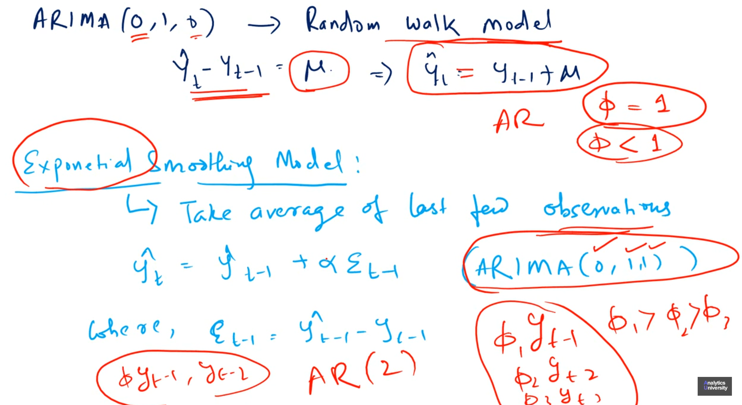

After stabilizing the variance(using box-cox transformation) difference is applied

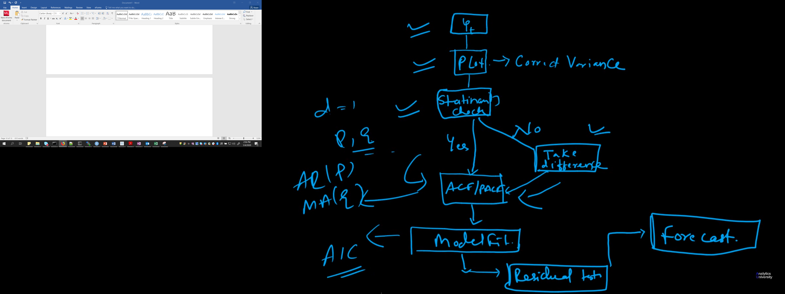

Multivariate time series

Panel Data: combines time series and cross section data(you don’t have time component)